**CENG 355 Proposal**

1. **General information**

1. Project Name: Mini Explorer

2. Team members: Duc Nguyen, Abiodun Ojo, Aldous Mendoza

3. Summary: The whole project intends to create a remote control car which consists of Raspberry Pi being the main component and other sensors to support different functions. The car will be controlled through an app and send data to a real-time database.

4. Background: It has always been hard to gather environmental data in small/hazardous places where humans can’t reach. This device is created to solve that problem. The sensors are the hardware from the previous semester, so we have a good understanding of their mechanism and potential.

1. **Technical information**
2. How to implement:

- Can either turn Raspberry Pi into a Wifi point, or use Bluetooth to connect the RC car to the app. Configurations on Raspberry Pi must be done in order to achieve this.

- PWM/Servo driver (PCA9685) is used to create and control the car’s movement.

- Distance sensor (VL53L0X) is used to detect any obstacles near the car while travelling

- Temperature & Humidity Sensor (HDC1008) is used to retrieve environmental readings

- Firebase is used in order to store users’ accounts and environment readings.

- Screens from the phone app:

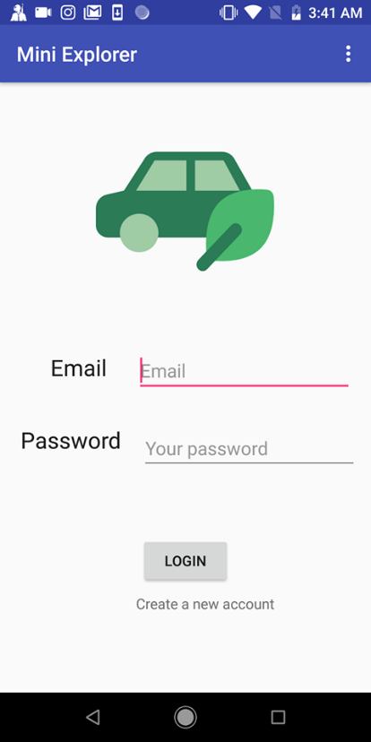 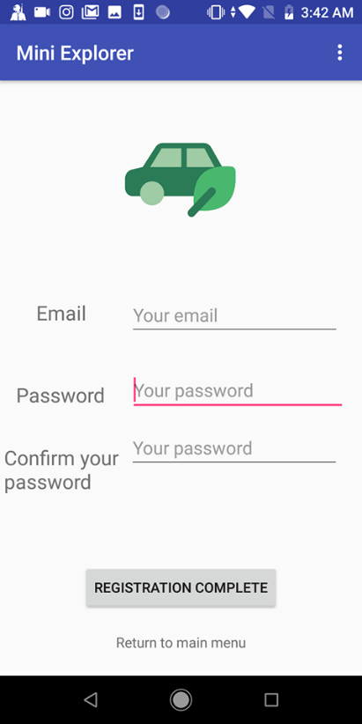

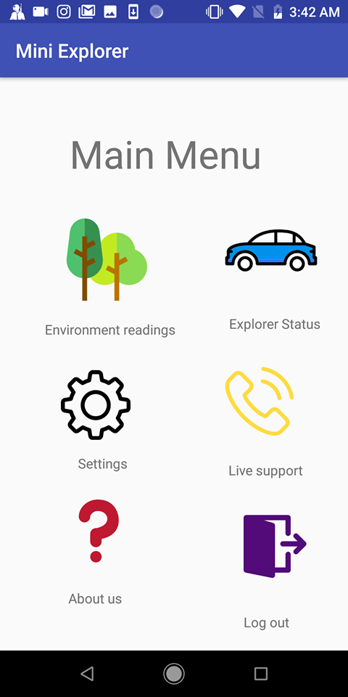 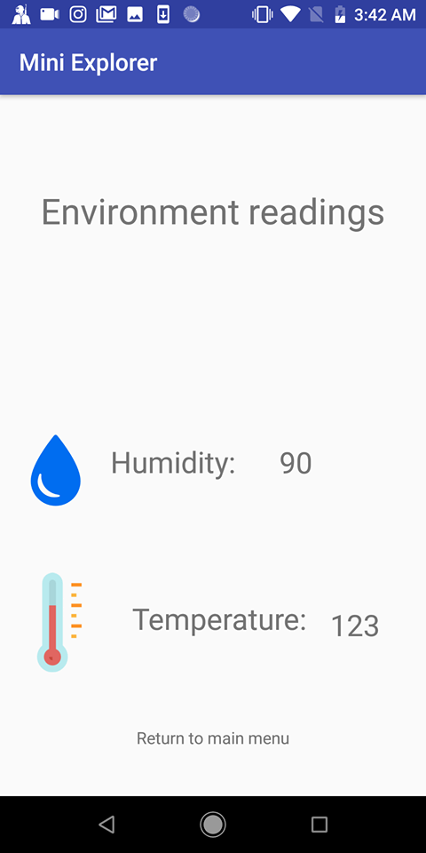

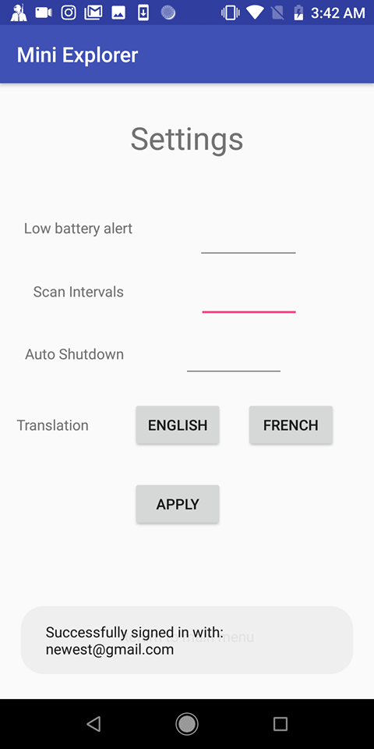 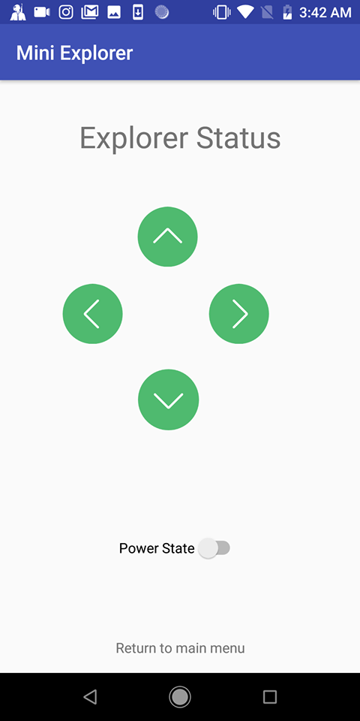

2. Time estimation: 3.5 months. If there is any problem, we will prioritize which functions should be definitely included and which ones are not necessary at the moment.

3. Originality: There have been many similar projects. However, our unique features are:

- The RC car will consist of two environment sensors: Distance & Temperature/Humidity.

- The project comes with an app that is very friendly to users.

- Data are stored in a real-time database and can be retrieved easily.

4. Test cases:

- The RC car can move.

- The car can transmit real-time data to database.

- The phone app can interact with the car, including controlling its motions and configuring its settings.

1. **Conclusion**

Mini Explorer is a very promising project for different fields. While there are certain challenges, it can have great uses for weather reporters, geologists, and travelers.